Twin Paradox? There is no Twin Paradox! (Really!)

Dr. Stephen M. Rodrigue
Yakima Valley Community College
Introduction

Many students encounter the Twin Paradox during an introduction to special relativity. Typically, the paradox is phrased in terms of a sample problem in which one twin travels to some distant star or other target and then returns to Earth, while the second twin remains on Earth. In the reference frame at rest with the Earth it can be shown that the traveling twin ages less than the Earthbound twin. The symmetry of the Lorentz transformations, in particular that of time dilation, is then invoked to indicate in the traveling twin’s rest frame, the Earthbound twin is the one that has traveled and therefore should age less. A seemingly obvious paradox exists, since each twin can’t age less than the other.
The problem as thus stated overlooks a key special relativistic concept: the aging intervals calculated in the Earth rest frame are timelike spacetime intervals, which are invariant in all inertial reference frames. Given the invariance of the timelike intervals, then all observers will agree that the traveling twin will age less than the Earthbound twin. If this is true, then how does time dilation symmetry exist?
A sample problem will be used to demonstrate how the Lorentz transformations maintain both the invariance of various spacetime intervals, including the timelike aging intervals of the twins, as well as exhibiting time dilation symmetry between corresponding timelike spacetime intervals from different reference frames. In addition, interesting features of non-Euclidean geometry will be highlighted, which are not well illustrated by standard Euclidean spacetime diagrams.
Sample Problem and Lorentz Transformations

A target of interest lies at a spacelike spacetime interval of 21 light-years from the Earth. A rocket travels to the target at velocity v/c = 21/29, so that in the Earth rest frame 29 years pass on Earth while the rocket travels to the target. Upon reaching the target, the rocket immediately rotates so as to return to Earth. During the return journey, 29 years are observed to pass on Earth as the rocket crosses a spacelike spacetime interval of 21 light-years.
Figure 1 depicts this rocket journey from the Earth to the target and back as observed in the Earth rest frame in a standard spacetime diagram. All general relativistic, Hubble expansion, and other corrections have been ignored so that calculations can be kept strictly special relativistic. The origin has been placed at the rocket arrival at target event to facilitate comparisons between different reference frames and enhance visualization of the effects of Lorentz transformation. Figure 2 illustrates the results of the Lorentz transformation between the Earth rest frame event spacetime coordinates and a frame at rest with the first half of the rocket motion, the outbound rocket. Figure 3 shows the results of the Lorentz transformation between the Earth rest frame event spacetime coordinates and a frame at rest with the second half of the rocket motion, the return rocket. Figure 4 depicts the standard spacetime diagram of the rocket journey in the rest frame of the rocket. This involves a spacetime rotation about the rocket when it arrives at the target, which is the origin in all four figures. In particular, both coordinates of the Earth, i.e., space and time, change signs due to this rotation. All event spacetime coordinates for the four reference frames, listed as (x, t), with units of light-years, are tabulated in Table 1.
Tables 2 and 3a, 3b show the coordinate differences (Δx, Δt) between various spacetime events and the calculated spacelike ($\sqrt{{∆x}^{2}-{∆t}^{2}}$) or timelike ($\sqrt{{∆t}^{2}-{∆x}^{2}}$) intervals, depending upon which difference is larger. Table 2 lists the spacelike intervals between corresponding locations of Earth and the target. All reference frames agree upon an invariant spacelike interval of 21 light-years between the Earth and target. Table 3a tabulates the timelike intervals between the Earth launch and target arrival, between target arrival and Earth return, and the sum, for both the Earth and target (which travel along parallel paths and thus experience the same timelike intervals). All reference frames agree upon timelike intervals of 29 years for each segment and a sum of 58 years. Table 3b shows the timelike intervals for the rocket travel between Earth launch and target arrival, between target arrival and Earth return, and the sum. All reference frames agree upon timelike intervals of 20 years for each segment and a sum of 40 years.
Time dilation effects can be seen by comparing corresponding row entries in the same table, such as the first two columns in the first row for Table 3a. The rocket 1st half (outbound) rest frame time difference of 42.05 is γ (= 29/20 = 1.45) times the Earth rest frame time difference of 29. This is the same time dilation that the Earth observes regarding the outbound rocket time, as shown by the first two columns in the first row in Table 3b. The Earth rest frame time difference of 29 is γ (= 29/20 = 1.45) times the rocket rest frame time difference of 20. Note that these two results do not just invert the aging intervals experienced by the two twins. Also observe that for all intervals which have two nonzero differences (both space and time), the correct velocity is calculated by dividing the space coordinate difference by the time coordinate difference. A special case of this occurs when comparing the corresponding entries of the rocket rest frames, e.g., the second and third column entries in row one or row two of Table 3b. The calculated velocity of v/c = ±60.9/64.1 = ±1218/1282 = ±2(21)(29)/(29² + 21²) equals the velocity calculated from the special relativistic addition of velocities formula. The corresponding γ for this velocity is γ = 3.205 = (29² + 21²)/20², and the corresponding time dilation of 64.1 = 20 times this γ.
Figure 5 compares the four rest frames. Note that the effect of Lorentz transformation is rotation and stretching of the quadrilateral shown in the Earth rest frame, as expected from linear algebra. Observe that the Euclidean nature of the five figures obscures the non-Euclidean features. All spacelike intervals between the Earth and target, in all diagrams, depicted as dashed lines, are of the same length, 21 light-years. These intervals generate one set of parallel sides of the quadrilaterals. All lightlike intervals for the Earth and target, in all diagrams, shown as thinner solid lines, are of the same length, 29 light-years (for each segment, or a total of 58 light-years for the sum of the two segments). These intervals generate the second set of parallel sides of the quadrilaterals. All lightlike intervals for the rocket, in all diagrams, illustrated by thicker solid lines, are of the same length, 20 light-years. These intervals lie along the diagonals of the quadrilaterals. Note that the Euclidean spacetime diagrams completely fail to indicate the lengths of the diagonals of all the quadrilaterals are equal, and that they are smaller than the lengths of the sides. These are remarkably significant non-Euclidean results which cannot be shown in standard Euclidean spacetime diagrams.
Conclusion

The Twin Paradox is seen to arise from an incomplete application of the principles of special relativity. The underlying assumption of the Twin Paradox, time dilation symmetry, of course must hold, but equally important, and overlooked in the statement of the paradox, is the invariance of spacetime intervals in all inertial reference frames. The aging intervals experienced by the twins are indeed invariant timelike spacetime intervals, so all inertial observers will agree that the traveling twin ages less than the Earthbound twin. In the frame of the rocket (traveling twin), the Earthbound twin travels a greater distance during a longer time, than what the Earthbound twin observes for the rocket twin. This greater observed difference is such that the time dilation as observed by the rocket twin is the same as the time dilation as observed by the Earthbound twin, preserving time dilation symmetry, yet also allows for the timelike interval between the start and end of travel to equal the invariant timelike interval observed for the Earthbound twin in all frames.
The typical Twin Paradox problem can be used to illustrate the effects of Lorentz transformation and emphasize interesting features of the non-Euclidean nature of special relativity. The standard spacetime diagrams, which are Euclidean, do depict well the rotation and expansion/contraction expected from linear algebra, but fail to accurately show the important special relativistic features, especially invariance, which are due to the non-Euclidean geometry connecting space and time. Comparing the calculation results with the limits of spacetime diagrams can help students develop a better appreciation of special relativity.

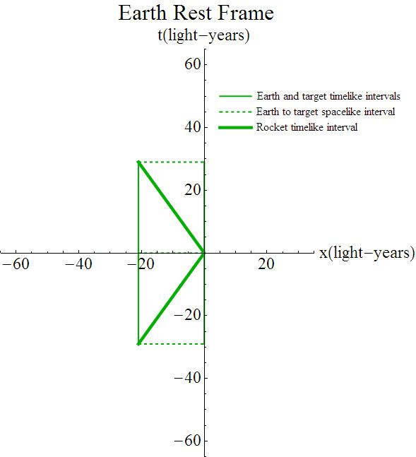
Figure 1 Earth Rest Frame, in which the rocket travels at velocity $\frac{v}{c}=±\frac{21}{29} \left(γ=\frac{29}{20}\right)$ relative to the Earth, with the + (-) for travel to (from) the target.

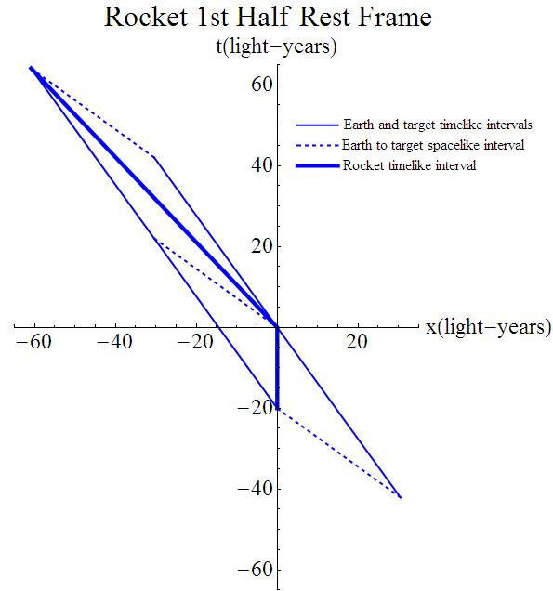
Figure 2 Rocket 1st Half Rest Frame, in which the Earth and target travel at velocity $\frac{v}{c}=-\frac{21}{29} \left(γ=\frac{29}{20}\right)$ relative to the outbound rocket, while the return rocket travels at velocity $\frac{v}{c}=-\frac{2(21)(29)}{{29}^{2}+{21}^{2}} \left(γ=\frac{{29}^{2}+{21}^{2}}{{20}^{2}}\right)$.

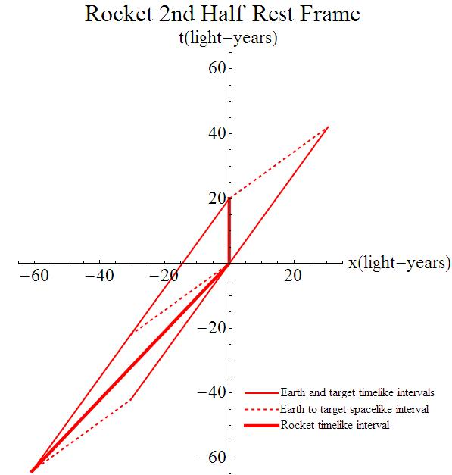
Figure 3 Rocket 2nd Half Rest Frame, in which the Earth and target travel at velocity $\frac{v}{c}=\frac{21}{29} \left(γ=\frac{29}{20}\right)$ relative to the returning rocket, while the outbound rocket travels at velocity $\frac{v}{c}=\frac{2(21)(29)}{{29}^{2}+{21}^{2}} \left(γ=\frac{{29}^{2}+{21}^{2}}{{20}^{2}}\right)$.

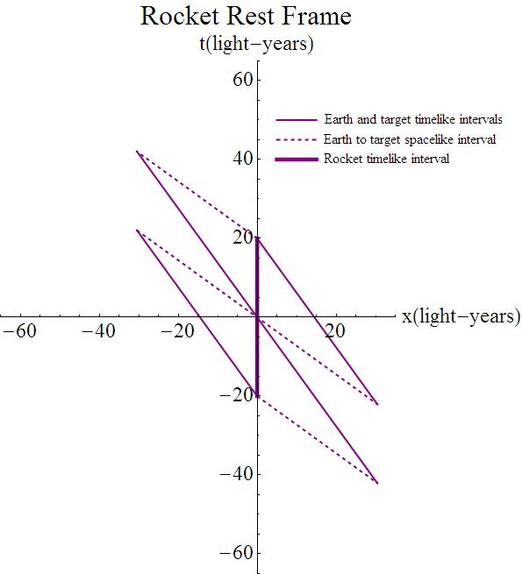
Figure 4 Rocket Rest Frame, in which the Earth and target travel at velocity $\frac{v}{c}=-\frac{21}{29} \left(γ=\frac{29}{20}\right)$ relative to the rocket. A rotation about the rocket occurs when it is at the target, the event with coordinates (0, 0).

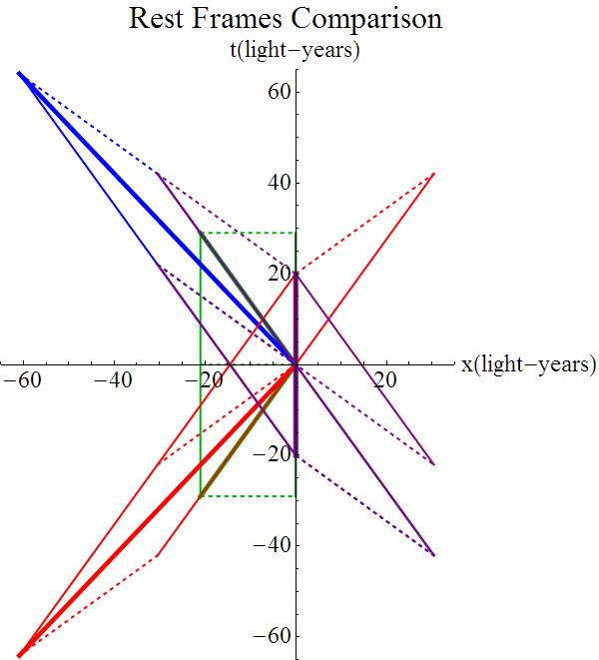
Figure 5 Comparison of the previous rest frames. Note that the Lorentz transformations rotate and dilate the original quadrilateral, but all dimensions of the quadrilaterals remain invariant.

Table 1 Event Spacetime Coordinates (in light-years)
Event Point | Frame
 | Earth | Rocket  1st Half | Rocket  2nd Half | Rocket
Launch - Earth (1) | (-21, -29) | (0, -20) | (-60.9, -64.1) | (0,-20)
Target (2) | (0, -29) | (30.45, -42.05) | (-30.45, -42.05) | (30.45, -42.05)
Arrival -Earth (3) | (-21, 0) | (-30.45, 22.05) | (-30.45, -22.05) | (-30.45, 22.05)¹
 |  |  |  | (30.45, -22.05)²
Target (4) | (0, 0) | (0, 0) | (0, 0) | (0, 0)
Return -Earth (5) | (-21, 29) | (-60.9, 64.1) | (0, 20) | (0, 20)
Target (6) | (0, 29) | (-30.45, 42.05) | (30.45, 42.05) | (-30.45, 42.05)

¹ before rotation in spacetime about rocket ² after rotation ³ spacetime coordinates given as (x, t) in units of light-years (technically, t coordinate should be ct)

Table 2 Spacelike Spacetime Intervals (in light-years)
Event Points  Earth to Target | Frame
 | Earth | Rocket  1st Half | Rocket  2nd Half | Rocket
Earth (1)  Target (2) | (21, 0)¹ | (30.45, -22.05) | (30.45, 22.05) | (30.45, -22.05)
 | 21² | 21 | 21 | 21
Earth (3)  Target (4) | (21, 0) | (30.45, -22.05) | (30.45, 22.05) | (30.45, -22.05)³
 |  |  |  | (-30.45, 22.05)⁴
 | 21 | 21 | 21 | 21³
 |  |  |  | 21⁴
Earth (5)  Target (6) | (21, 0) | (30.45, -22.05) | (30.45, 22.05) | (-30.45, 22.05)
 | 21 | 21 | 21 | 21

¹ spacetime coordinate differences (Δx, Δt) in light-years between listed event points ² spacelike spacetime interval $\sqrt{{(∆x)}^{2}-{(∆t)}^{2}}$ in light-years ³ before rotation in spacetime about rocket ⁴ after rotation

Table 3a Earth and Target Timelike Intervals (in light-years)
Event Points | Frame
 | Earth | Rocket  1st Half | Rocket  2nd Half | Rocket
(1) to (3),  (2) to (4)¹ | (0, 29)³ | (-30.45, 42.05) | (30.45, 42.05) | (-30.45, 42.05)
 | 29⁴ | 29 | 29 | 29
(3) to (5),  (4) to (6)² | (0, 29) | (-30.45, 42.05) | (30.45, 42.05) | (-30.45, 42.05)
 | 29 | 29 | 29 | 29
Sum of the above intervals | 58 | 58 | 58 | 58

¹ Earth launch to target arrival, Earth points first, then target points – Earth and target experience the same timelike intervals between the two event points listed for each ² target arrival to Earth return, Earth points first, then target points ³ spacetime coordinate differences (Δx, Δt) in light-years ⁴ timelike spacetime interval $\sqrt{{(∆t)}^{2}-{(∆x)}^{2}}$ in light-years

Table 3b Rocket Timelike Intervals (in light-years)
Event Points | Frame
 | Earth | Rocket  1st Half | Rocket  2nd Half | Rocket
Earth Launch (1) to Target  Arrival (4) | (21, 29)¹ | (0, 20) | (60.9, 64.1) | (0, 20)
 | 20² | 20 | 20 | 20
Target Arrival (4) to Earth  Return (5) | (21, 29) | (-60.9, 64.1) | (0, 20) | (0, 20)
 | 20 | 20 | 20 | 20
Sum of the above intervals | 40 | 40 | 40 | 40

¹ spacetime coordinate differences (Δx, Δt) in light-years
² timelike spacetime interval $\sqrt{{(∆t)}^{2}-{(∆x)}^{2}}$ in light-years

